Database Modeling

Sample data

* Translate user stories and personas to sample data
* Create schema
* Flush out the database modeling ideas
* (By Chuan)

Database relation modeling

* Translating the user requirement into sensible entities and relations
* (By Chuan)

Version 1

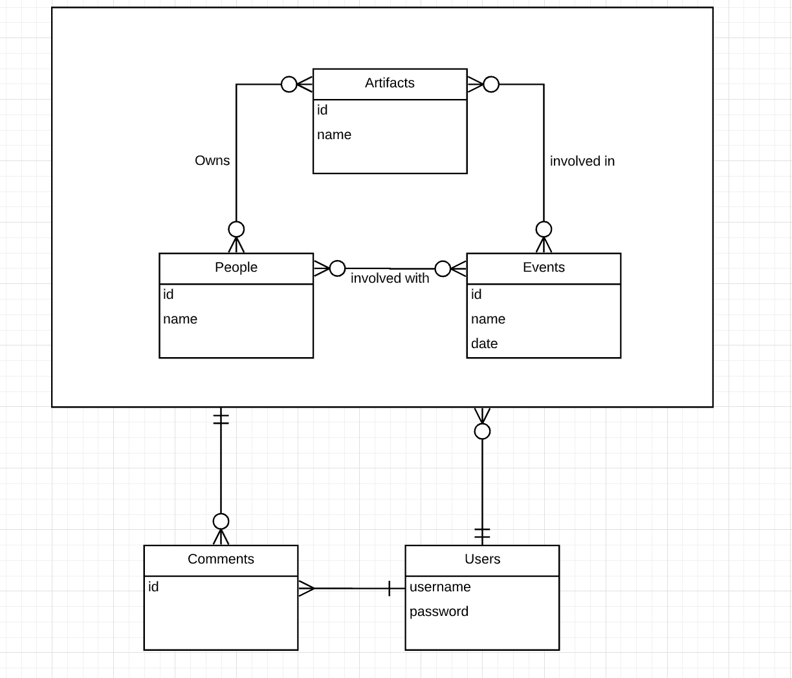

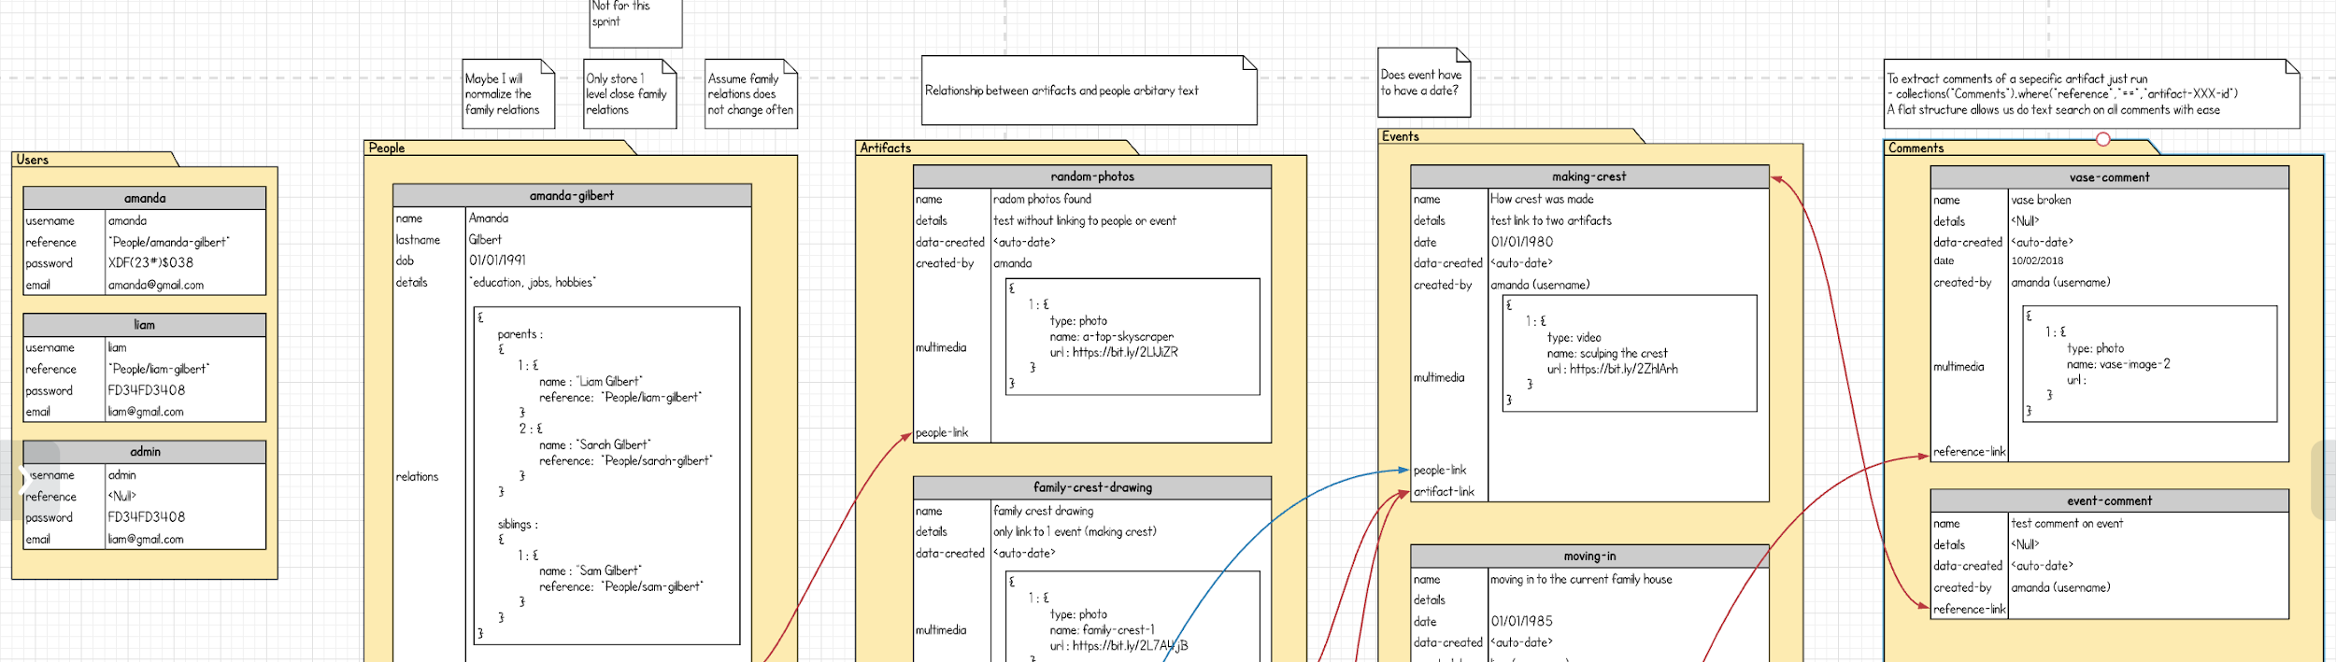

Version 2

* Removed multimedia
* Removed following relations
  + People to Events
* Added constraints
  + People must belong to a document in Artifacts
  + Events must belong to a document in Artifacts

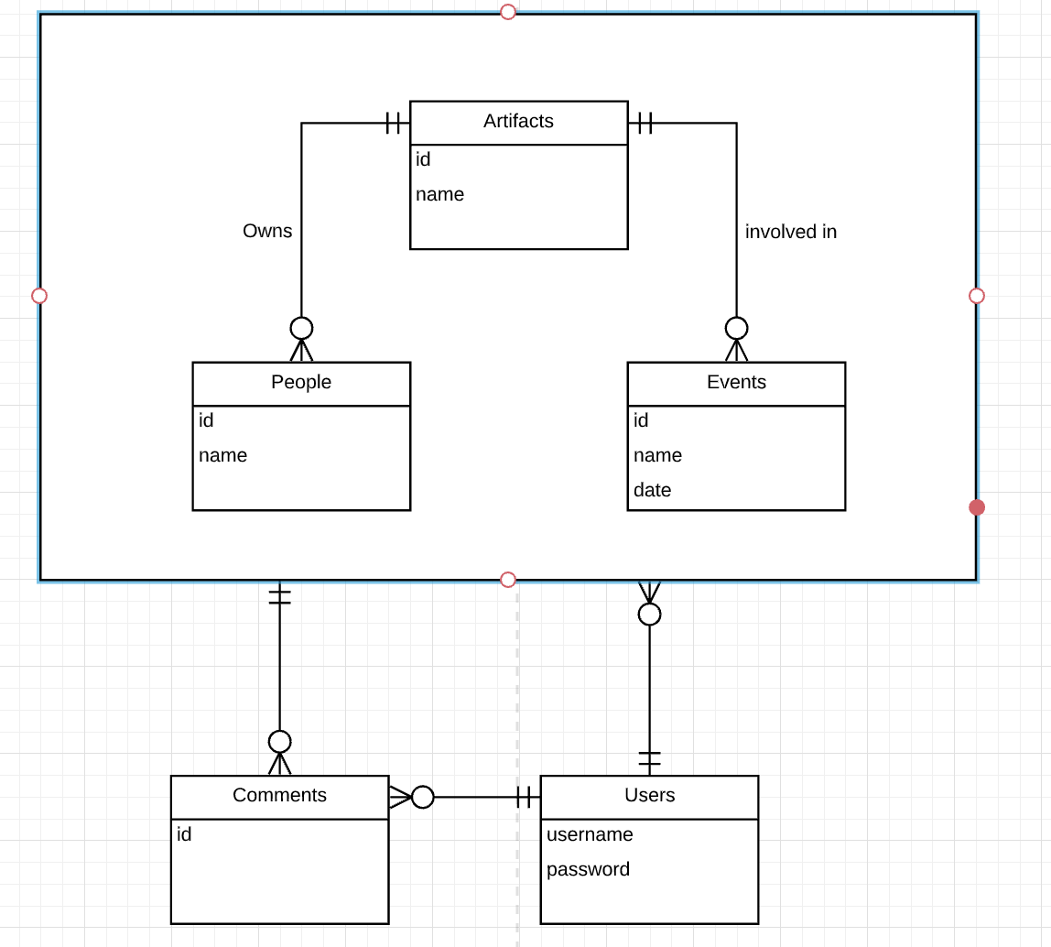

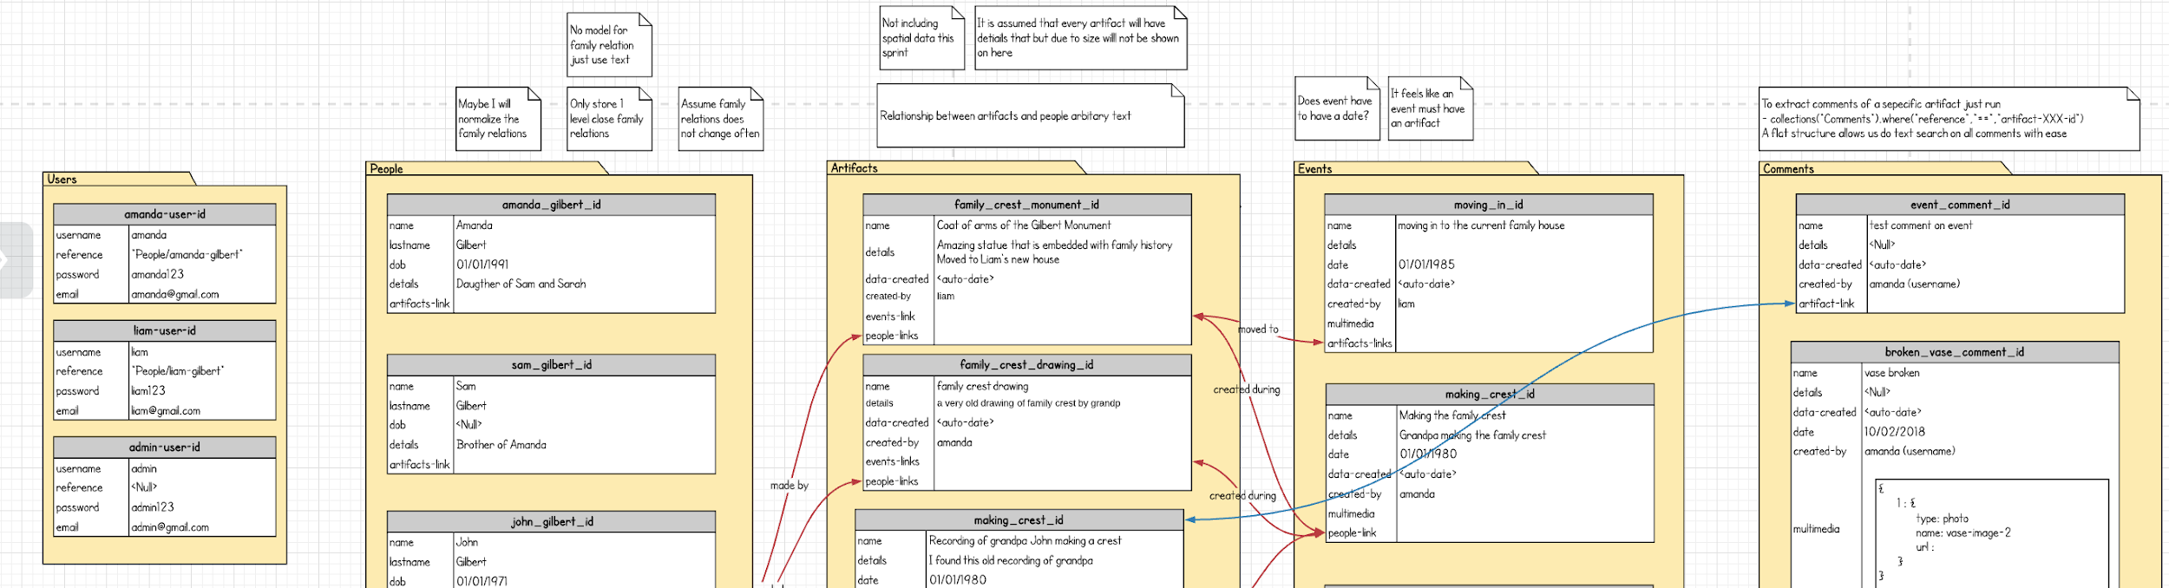

Query

Rest the database

* Linked to Firebase
* Buttons that delete all documents and upload the sample data.
* (By Chuan)

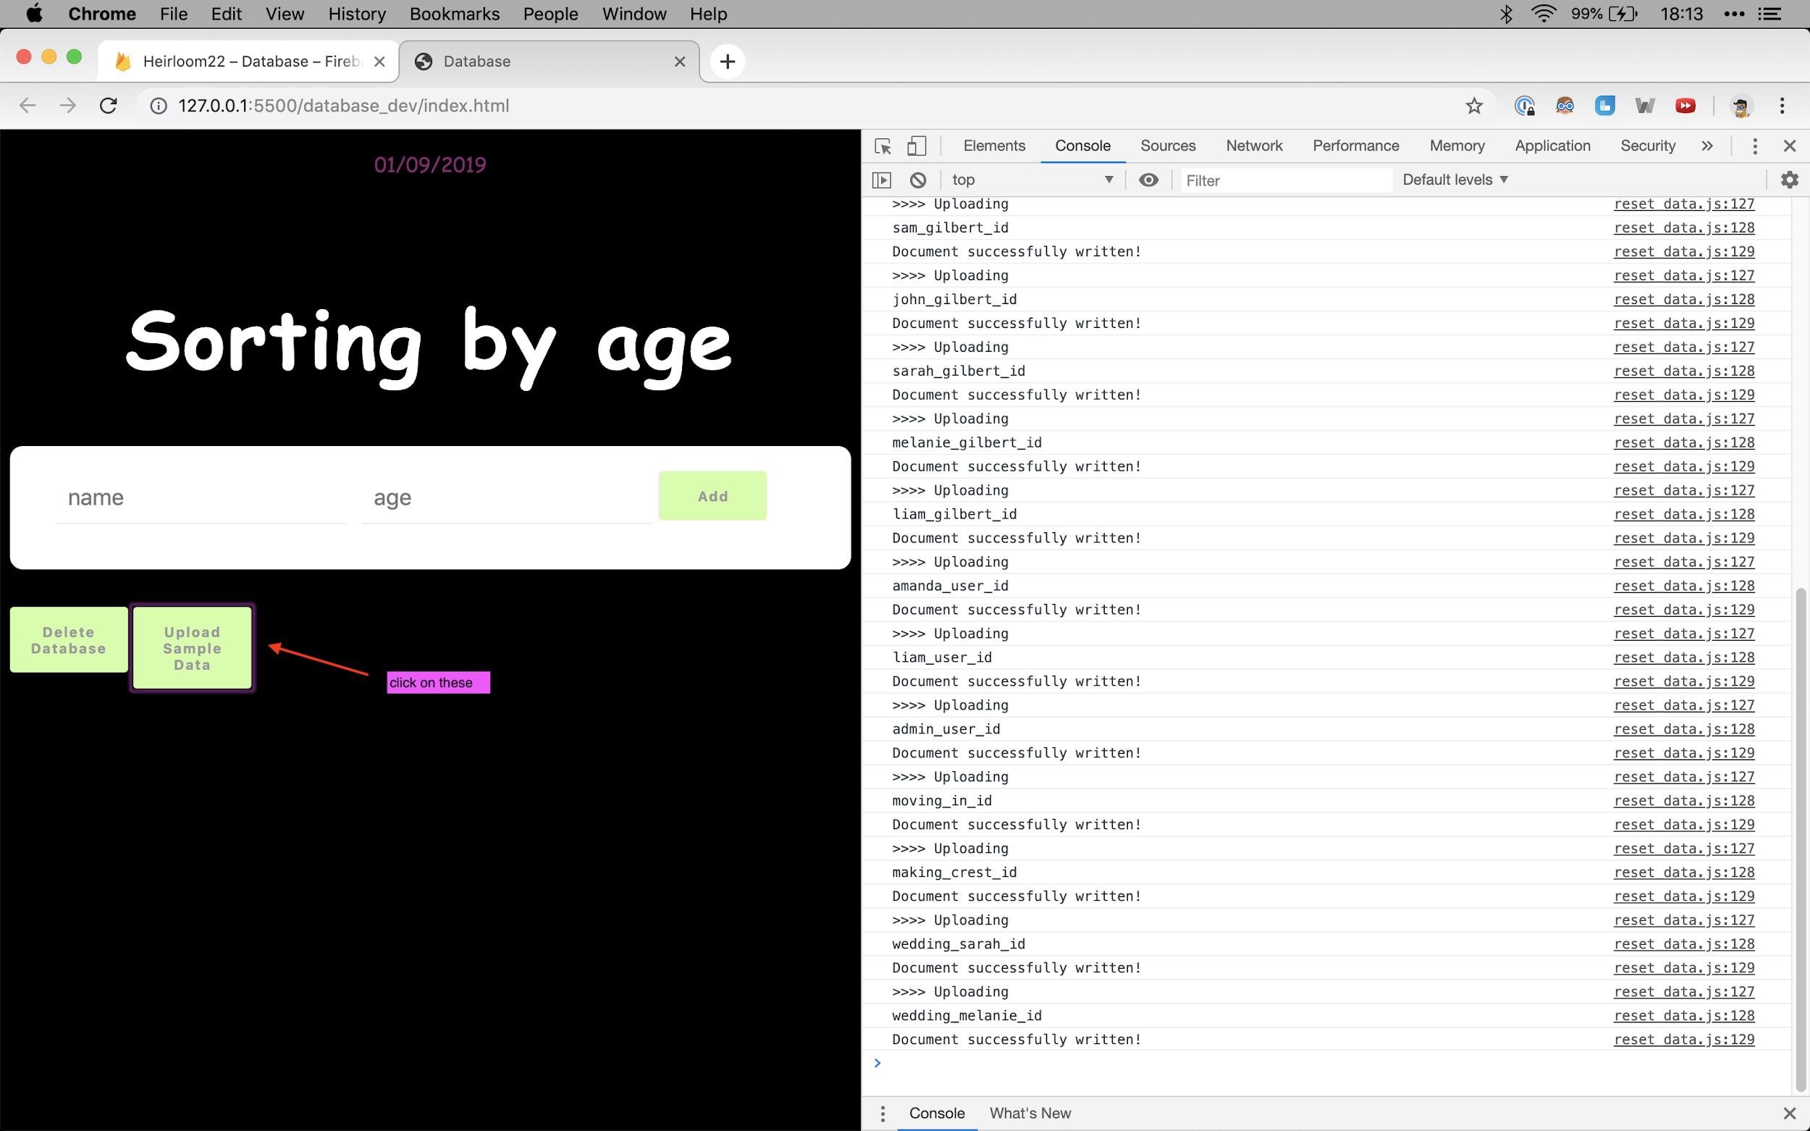

Architecture diagrams

* Here we used the suggested c4 model introduced in week 6 lecture
* Based on the guidelines from <https://c4model.com/>
* (By Chuan and Oliver)

Version 1

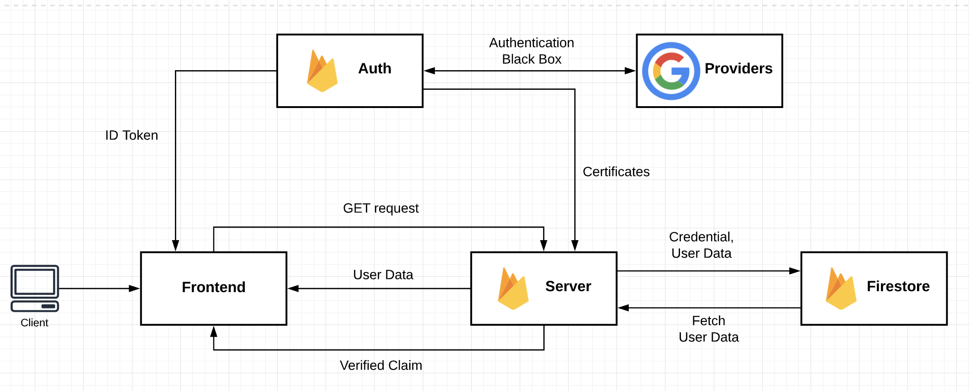

Version 2

* Translated version 1 into “level3: Component Level Diagram”

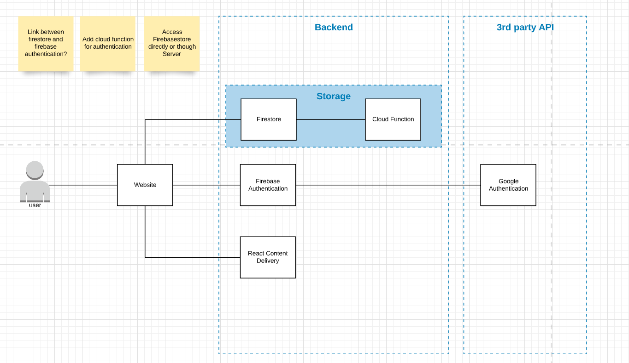

Version 3

* Added details version
* Added relations

